NTBLCP MOBILE APK SET UP
- When you click on the APK sent through the WhatApp, the above information will come up. Click on Open file

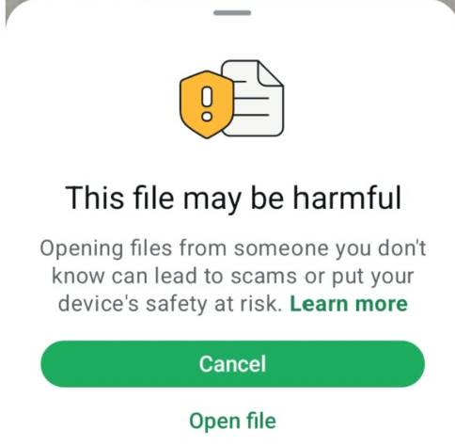

- Then later it will recommend for the App scan. Click on Scan app
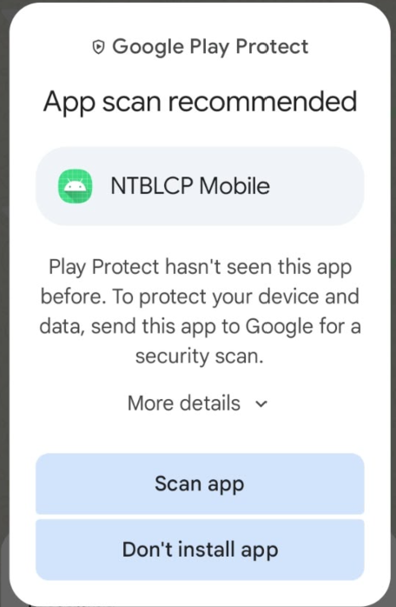
- When it finishes scanning, you can Install:
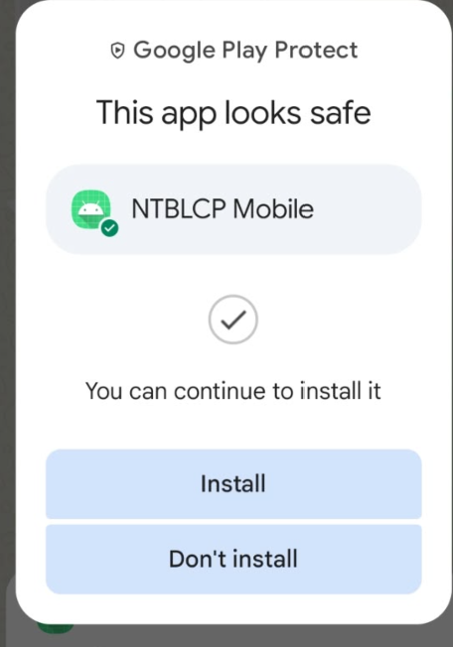
- When it finished installing, you can allow the mobile access to the location:

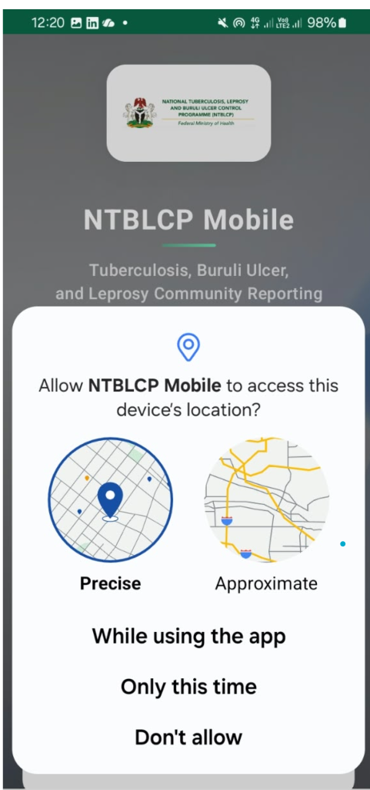
- Enter the username and password of the DHIS 2 instance. Note, you have to be connected to the internet in order to set up the device as it pulls from the DHIS 2 server

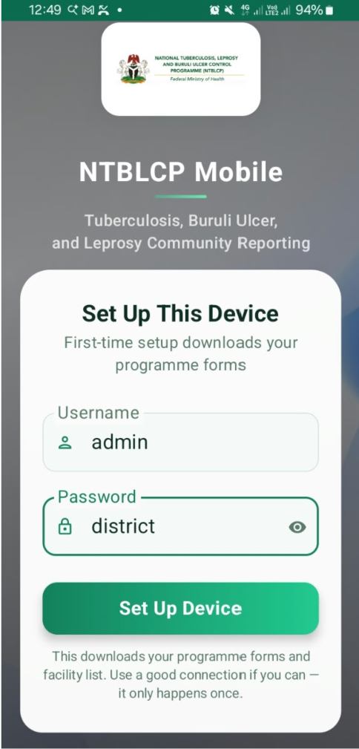
- Once you login, click on the TB Case Surveillance and then Navigate through the forms
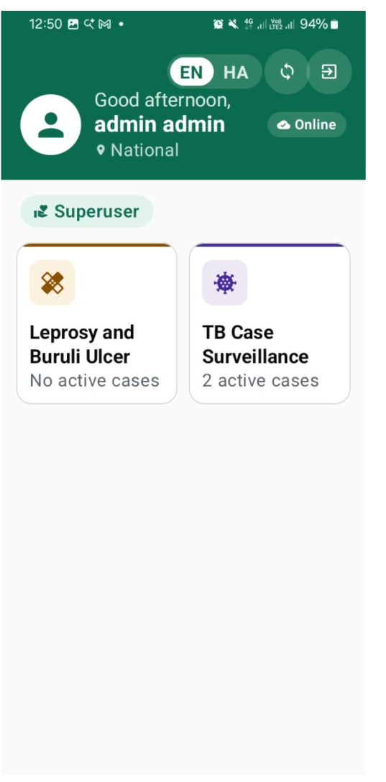 | 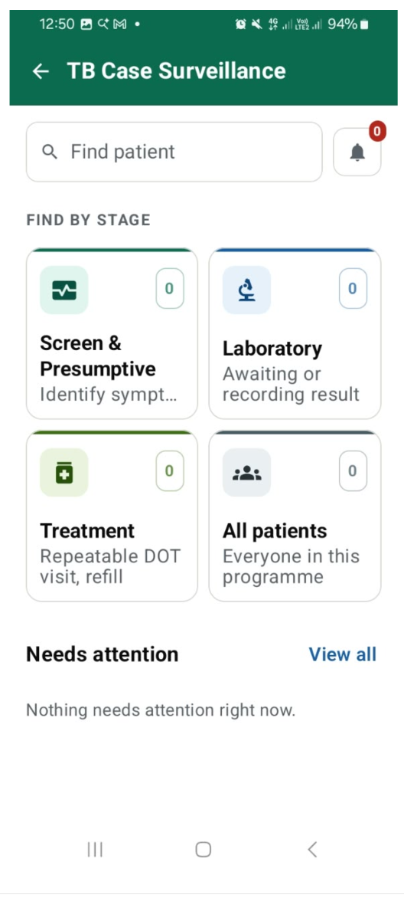

- You can search by patient using either ID or name
- Find by Stage shows you all records at each stage

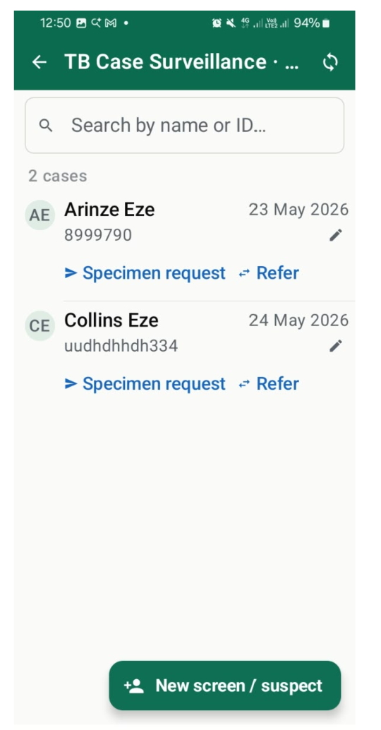 | 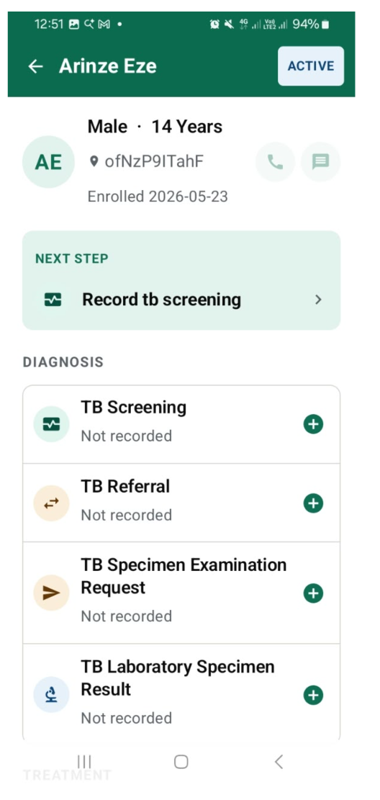
- Select the patient to view additional details and encounter history with available forms for each stage and required documentation
- Each form has a status to indicate if the record has been captured

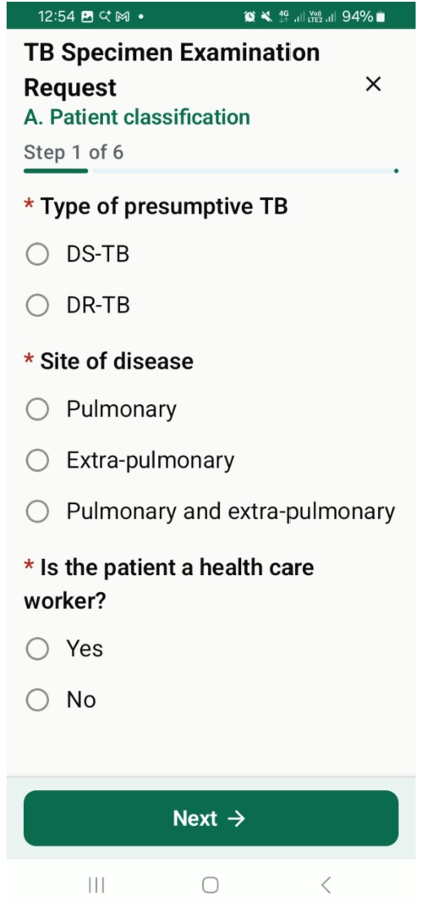

- You can select a specific form and update the relevant fields

